NATIONAL UNIVERSITY OF COMPUTER AND EMERGING SCIENCES

Asd

SE-2002 – Software Design & Architecture Lab

Lab Instructor: Zarnain Maryam Awan “zarnain.maryam[@nu.edu.pk](mailto:jaffar@nu.edu.pk)”

Lab 11

**Deployment Diagram**

A deployment diagram is a UML diagram type that shows the execution architecture of a system, including nodes such as hardware or software execution environments, and the middleware connecting them. Deployment diagrams are typically used to visualize the physical hardware and software of a system. Using it you can understand how the system will be physically deployed on the hardware.

Deployment diagrams help model the hardware topology of a system compared to other UML diagram types which mostly outline the logical components of a system.

***Deployment Diagram Notations***

In order to draw a deployment diagram, you need to first become familiar with the following deployment diagram notations and deployment diagram elements.

***Nodes***

A node, represented as a cube, is a physical entity that executes one or more components, subsystems or executable. A node could be a hardware or software element.

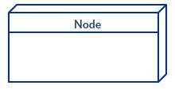

***Artifacts***

Artifacts are concrete elements that are caused by a development process. Examples of artifacts are libraries, archives, configuration files, executable files etc.



***Communication Association***

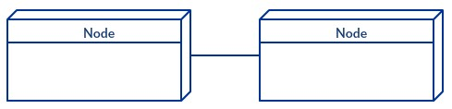

***Devices***

This is represented by a solid line between two nodes. It shows the path of communication between nodes.

A device is a node that is used to represent a physical computational resource in a system. An example of a device is an application server.

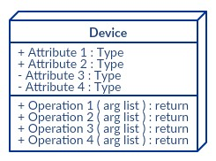

***Deployment Specifications***

Deployment specifications is a configuration file, such as a text file or an XML

document. It describes how an artifact is deployed on a node.

**Example 01**

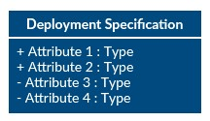

The example shows the topology of a human resources system, which follows a classical client/server

architecture

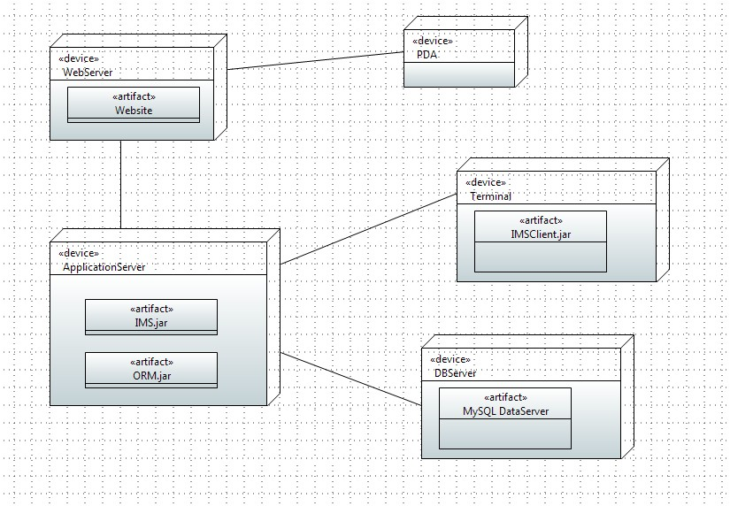

***Example 02***

Following deployment diagram represents the working of HTML5 video player in the browser.

